LC100 Series inductance capacitance table is divided into LC100-S-and LC100-A type two models, LC100-S is a standard type, a small capacitance 0.01pF-10uF, small inductor 0.001uH-100mH, large inductance 0.001mH-100H three stalls while LC100-A type is a full-featured, in addition to the above three stalls, was added to the 1uF-100mF large electrolytic capacitor test function, all stalls are automatic range.

This product relative to the finished product on the market inductance capacitance meter (such as 6243 series) in the small value of the test has an absolute advantage is the accuracy and minimum resolution, and has a flexible line calibration measurement accuracy can be maintained at all times. Instrument does not use any potentiometer adjustment, calibration parameters are fully stored in internal FLASH microcontroller, power-down is not lost, other than the potentiometer calibration methods must be accurate and convenient.

LC100-A basic technical indicators:

Measurement accuracy: 1%

Capacitance Measuring Range: 0.01pF-10uF

Minimum resolution: 0.01pF

Inductance Range: 0.001uH-100mH

Minimum resolution: 0.001uH

Large inductance measurement range: 0.001mH-100H

Minimum resolution: 0.001mH

Large capacitance measurement range: 1uF-100mF

Minimum resolution: 0.01uF

Test Frequency: capacitors, inductors file is about 500kHz, large inductance of about 500Hz,

Can display current test frequency value

Effective display digits: 4

Display: 1602

Power supply: miniUSB interface to take power or 5V power supply

Using SMD component soldering, stable and reliable!

LC100-A joined the large capacitor 1uF-100mF measurements, the following figure is a measure of six 4700uF capacitor in parallel with a large capacitance, measured values ​​28.7mF, equivalent to each capacitor 4.78mF, 28.7mF is beyond the capacity of ordinary capacitance meter range, while the instrument test range direct 100mF

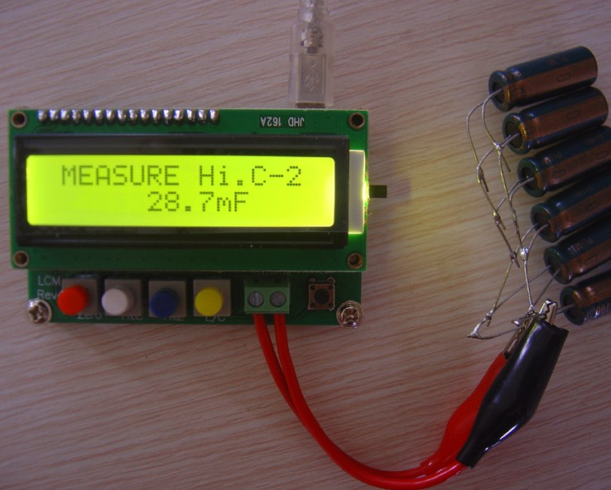

In the small capacitor, small inductors and large inductive test, LC100-A and LC100-S are the same, the following order LC100-S as an example:

The following image is an example of measuring small capacitance, can be seen from the picture, the resolution has been reached 0.01pF, then you are sure to pay attention to the impact test clip to keep the test clip in the absence of access capacitance normalized 0, then access capacitance as possible after the test clip to keep the same relative position, this is useful for testing small inductor is the same.

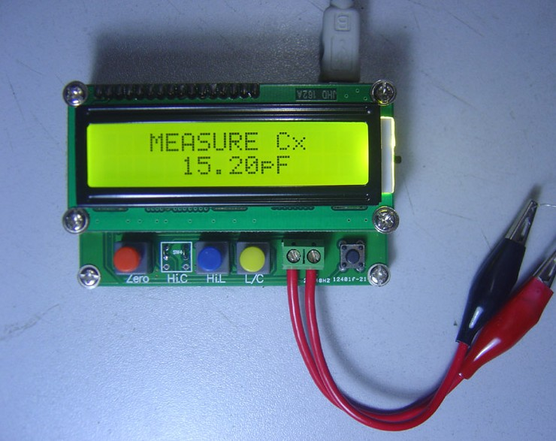

The second image is an example of measuring small inductor, seen from the picture, with a wire around the four rings hollow coil, test results 0.058uH, this result is equivalent to 58nH, for the 6243 class of the instrument absolutely undetectable this inductive, this is the advantage of this instrument

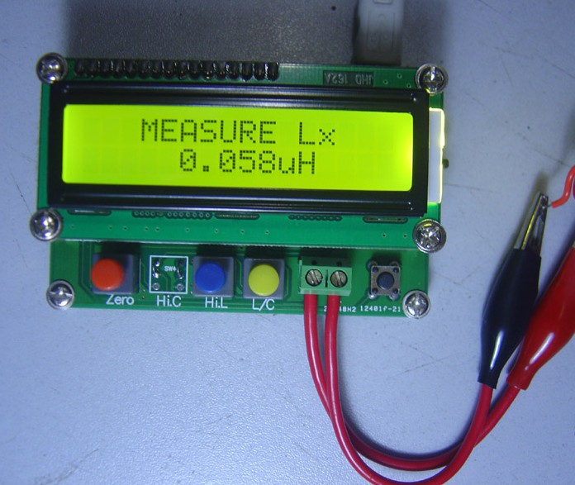

The third picture is a measure of a 0.22uF's safety capacitor, the measurement results of the figures is very stable, give you a hint here, if you are using the test results found beating very powerful, that this stability is poor or high-frequency capacitance feature is not good, a good result will be displayed very stable capacitance.

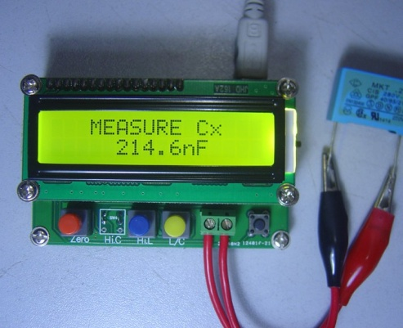
The fourth picture is the view measuring inductance, the current test frequency, using the method is the measurement of time by pressing the black button inductance, capacitance test can also be used for the same method to see.

