Description: (support the latest version of saleae logic 1.1.15)

Sampling rate up to: 24 MHz

Logic for each channel sampling rate up to 24M / seconds. General applications around 10M, which is sufficient for all occasions.

8-channel

Logic 8 inputs - can be collected simultaneously. Then to signal analysis, such as I2C, UART and other sampling and analysis.

10 billion samples

Logic can sample up to 10 billion everything, lets you capture even the most elusive events.

Voltage range

Logically: 5V voltage, accepting 5.25 V, a standard 0.8V CMOS logic low threshold. 2.0 V logic high. About 1 MΩ input impedance is also seeing more specifications (10 pF)

Protection

Protection against overvoltage condition logic input resistance, and a buffer chip. Better protection equipment safety.

Support for the latest version: 1.1.15 Version:
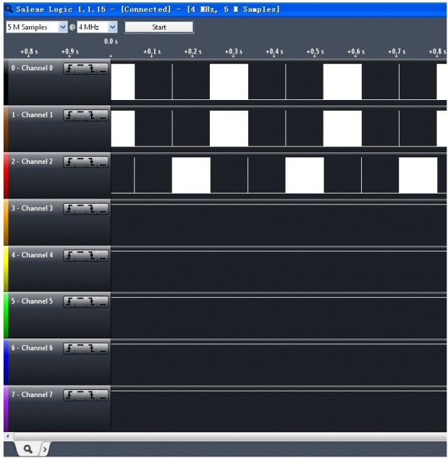
Serial Decoding:

