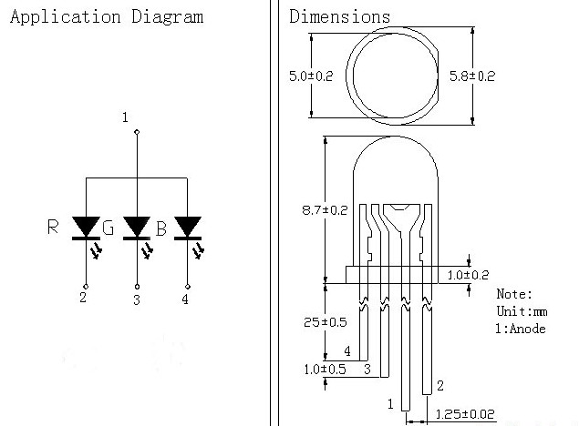

Red: Wavelength: 630-640nm MCD: 1000-1200MCD Voltage: 1.8-2.0
Green : Wavelength: 515-525nm MCD: 3000-5000MCD Voltage: 3.2-3.4
Blue: Wavelength: 465-475nm MCD: 2000-3000MCD Voltage: 3.2-3.4

Diameter 5MM, a disk, transparent, legs, hair red, green and blue full-color LED, common anode, bright light-emitting diodes. Pitch 1mm. Internal electrode biggest feet 2 feet, that is common.

Please add some tests while limiting resistor, it will easily burn LED, resistance can be a few hundred to 1000 in Europe.

